IT Infrastructure Task 2 Ubuntu Server DHCP and DNS
This report documents the Ubuntu Server virtual machine, DHCP address assignment, and DNS resolution tests.

Building and configuring ubuntu server
Firstly, set the machine name of my student ID and choose the ubuntu server ISO disk
The VirtualBox wizard identifies the new Ubuntu Server virtual machine and points it to the Ubuntu 22.04.5 installation ISO. The VM name distinguishes this lab server from the client machine used later.
Setting password and username
The unattended-installation screen assigns the initial account and host name. These credentials are for the lab VM; a real server would need a unique strong password kept out of screenshots.
Set up the hardware
The hardware page allocates about 5 GB of memory and four virtual CPUs. This gives the guest enough resources for the later DHCP and DNS services while leaving resources for the host.
Configure the host-only adapter and NAT network in the virtual box. The host-only adapter creates a private network between our host computer and the guest VMs and NAT network to allow your guest VMs to access external networks.
The host-only network is configured as 192.168.56.0/24, with the host adapter at 192.168.56.1. It provides a private path between the host and guest VMs for the service tests.
Adapter 1 connects the Ubuntu server to that host-only network. The selected adapter is the one that later receives the 192.168.56.118 address and serves lab clients.
Adapter 2 uses a NAT Network. This separate connection gives the VM an outbound route for package downloads without placing the lab services directly on the external network.
The installer starts with English selected. This choice determines the language of the remaining setup screens and does not affect the network configuration.
Select ubuntu default installation for experience full functionality:
The standard Ubuntu Server installation is selected rather than the minimized option. It provides the normal set of server utilities used in the following tasks.
Choose to use an entire disk:
The guided storage screen selects the virtual disk for installation. The choice applies only to the VM's virtual disk, which the installer will partition and format.
In the default setting, ubuntu server has a lot of free space at the start. Therefore, give space to our ubuntu file system by adjusting the disk space:
The root logical volume is expanded to about 79.5 GB and formatted as ext4. Enlarging the root filesystem makes the virtual disk space available to the installed operating system.
The storage summary confirms the root and boot filesystems before installation. This check matters because accepting the layout writes the partitions to the virtual disk.
After that, reboot the server
The installer reports that system configuration has completed and offers a reboot. Rebooting starts the newly installed operating system from its virtual disk.
The login screen shows that Ubuntu Server boots and accepts the configured account. It is the starting point for the service installation commands that follow.

Configure DHCP
The package index refresh is attempted before installing DHCP. Updating package lists helps the package manager locate current software versions; any mirror errors should be resolved if installation cannot continue.

Task 1: Download isc-dhcp-server
The installation command checks for isc-dhcp-server and reports that the package is already present. This package supplies the DHCP daemon that will lease addresses to clients.
The interface output shows 192.168.56.118 on the host-only side and 10.0.2.12 on the NAT side. The DHCP service must use the 192.168.56.x interface so that it reaches the lab client.

Task 2: Configure the DHPC Server.
In /etc/default/isc-dhcp-server, configure the enp0s3 as the interface that our DHCP server should listen for incoming DHCP requests:
The default DHCP service file is opened for editing. This file selects which network interface accepts incoming DHCP requests.
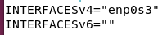
INTERFACESv4 is set to enp0s3 and the IPv6 field is left empty. That confines the IPv4 DHCP service to the host-only network shown in the earlier interface output.
Next, configure DHCP settings in /etc/dhcp/dhcp.conf:
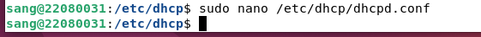
The main dhcpd.conf file is opened to define lease behavior and the address pool. The daemon reads this file when it starts or restarts.
The global settings give clients a 600-second default lease and a 7200-second maximum lease. Dynamic DNS updates are disabled, and authoritative mode marks this server as the DHCP authority for the lab subnet.
The accompanying table explains the global lease and authority settings. A short lease is convenient for a lab because clients can obtain revised settings quickly after changes.
The subnet block offers addresses from 192.168.56.110 through 192.168.56.130 and supplies DNS and domain options. The router option is set to 192.168.56.255 in the screenshot, but that is the /24 broadcast address, not a usable gateway; it needs a valid router address if clients require routing.
The subnet table translates the DHCP directives into client-facing settings. The address range defines the pool, while the DNS, subnet mask, and router options are delivered with each lease; the router value noted above should be corrected.

Task 3: Enable DHCP and Firewall
Start DHCP service by the above commands and verify by checking the status whether service is active:
The service is started and enabled with systemctl. Starting runs it now, while enabling asks Ubuntu to launch it automatically at boot.
The status output shows isc-dhcp-server as active and running. This confirms the process started, though a client lease is still needed to verify end-to-end DHCP behavior.
Check the netstate of DHCP Server to check the running port:
The socket check shows dhcpd listening on UDP port 67. That is the server-side DHCP port used to receive client requests.
Enable the ubuntu firewall then allow port 67 and 68 on the interface using DHCP
UFW is enabled on the server. Turning on a firewall restricts traffic according to its rules, so required DHCP traffic must be allowed before testing clients.
The displayed UFW command adds an incoming UDP 67 rule on enp0s3 for requests originating from client port 68. This permits DHCP requests on the lab interface.
Check the firewall status
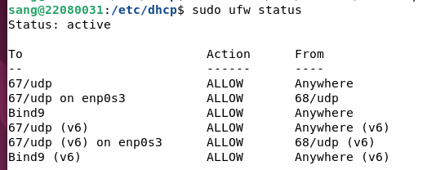
The firewall status confirms that UFW is active and lists the DHCP rules. The screenshot also shows a BIND rule, which belongs to the later DNS portion of the lab.

Task 4: Set up Ubuntu client
Now go to the guest machine and enable the DHCP request by configuring the /etc/network/interfaces with the following commands:
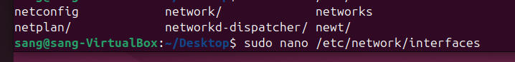
The client opens /etc/network/interfaces to configure its lab adapter. That file is used here to request an address automatically rather than assigning one by hand.
The interface stanza brings up enp0s3 at startup and sets it to use DHCP. On a system managed by NetworkManager or Netplan, the active network manager must also be considered for this setting to take effect.
The configuration table explains the loopback and client-interface directives. The loopback entry keeps local host communication available, and the enp0s3 entry requests a DHCP lease.
Then, restart the network service
NetworkManager is restarted after the client setting is changed. Restarting the network service makes the client renegotiate its connection and obtain current DHCP options.

Task 5: Test the DCHP connectivity
Ubuntu client network information:
The client interface output shows a 192.168.56.117 address on enp0s3. Because it lies inside the configured pool, it supports that the client received a lease from the lab network.
Server DHCP lease list:
(the hostname is different in this image is because I came back after setting up mail server and redo all the steps)
The server lease list records the client's MAC address and 192.168.56.117 lease. The hostname differs because the lab was repeated later; the matching address and client entry are the relevant evidence.
The MAC, IP, Hostname and Validity date of the Ubuntu client appears in the server’s DHCP lease list, so the configurations are done successfully.

DNS

Task 1: Install DNS Server
Install bind9 to run DNS service
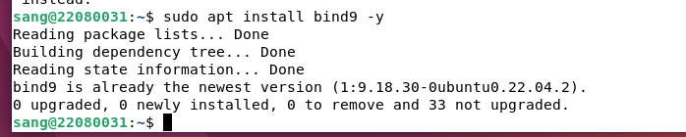
The BIND9 installation command reports that the DNS package is available. BIND provides the named service used for forward and reverse name resolution.
Confirm the installation
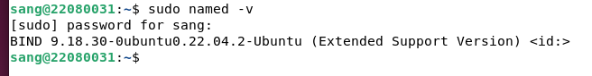
The named version command confirms that the BIND executable is installed. It verifies the software version, not yet that the DNS service is serving the new zone.

Task 2: Configure the DNS Server
Set up the /etc/hosts file to translate the hostnames (22080031.example.com) to IP addresses (192.168.56.118):
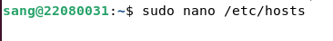
The server opens /etc/hosts to map its local name before editing DNS. This local file affects resolution on the server itself and is separate from the records BIND will serve to clients.
The hosts entry associates 22080031.example.com with 192.168.56.118. It allows the server to resolve that name locally while the DNS zone is being built.
Then in “/etc/bind/named.conf.options”, set default behaviors and parameters for the DNS server's operation:
The named.conf.options file is opened for the server-wide DNS settings. These options control recursion, listening interfaces, forwarding, and zone-transfer behavior.
Edit the recursion, listening IP address, allow transfer and forwarders IP
The configuration enables recursive queries, listens on 192.168.56.118, disallows zone transfers, and forwards unresolved names to two external resolvers. Listening on the lab address makes the service reachable by the client.
The option table describes the purpose of each BIND directive. In particular, allow-transfer none prevents other DNS servers from copying the zone, while forwarders are used for names outside the local zone.
After that, in /etc/bind/named.conf.local file, configure the DNS zones to specify the zone name, zone type and the DNS record location for forward and reverse zone:
The named.conf.local file is opened to register the lab's authoritative zones. BIND uses these declarations to locate each zone's record file.
The forward zone example.com points to db.example.com, while the reverse zone for 192.168.56.0/24 points to db.56.168.192. Both zones are declared as primary zones on this server.
The zone table explains how forward records map names to addresses and reverse records map addresses back to names. The file paths identify where BIND will read those records.
To properly configure DNS records, use the db.local file as a correct format template to configure db.example.com by copying the template to db.example.com file:
The default db.local file is copied to create the forward-zone file. Using the supplied template provides the required DNS record structure before the lab-specific records are edited.
Then edit the DNS record in db.example.com:

The new db.example.com file is opened for editing. Its contents will define the authoritative records for example.com rather than relying on the default localhost template.
The forward-zone screenshot shows the SOA and NS records plus A records for ns1, www, and the student-named host at 192.168.56.118. These A records let clients resolve those names to the server.
The record table expands the SOA timers, nameserver entry, address records, and the IPv6 localhost entry. These values control zone metadata and the names that clients can look up.
Then the same configuration will be done on reverse DNS lookup in /etc/bind/db.127 file:
The reverse-zone template is copied and opened as db.56.168.192. This creates the file that answers reverse lookups for addresses in the 192.168.56 subnet.
The reverse-zone file is opened for editing after the copy. Its PTR records must use only the last octet of an address because the other octets are represented by the zone name.
The reverse-zone screenshot assigns PTR records for address .118 to host names in example.com. A PTR query for 192.168.56.118 can therefore return a host name.
After all the setup, using checkconf and in-add.arpa to check the syntax error in every configuration file:
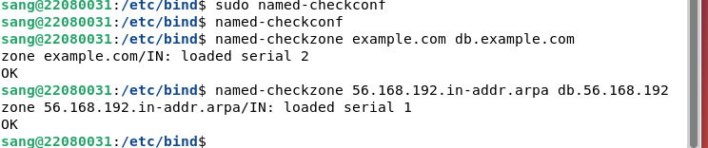
The named-checkconf and named-checkzone commands report that the configuration and both zones load successfully. These syntax checks catch malformed DNS files before client testing.

Task 3: Run the DNS server
Restart the DNS service and check its status.
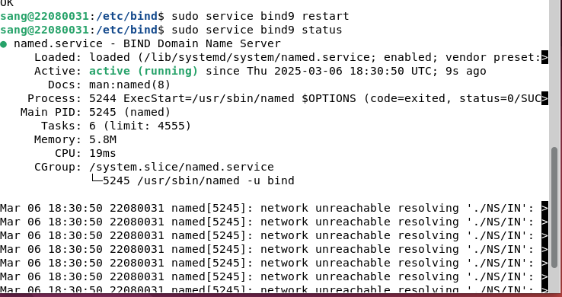
The BIND service is restarted and its status is shown as active. Restarting loads the newly edited zone files into the running DNS server.

Task 4: Verify DNS
rm /etc/resolv.conf to remove outdated or conflicting configurations:
The old /etc/resolv.conf link is removed before changing the server's resolver settings. This is a lab-specific change; on a managed Ubuntu system, resolver configuration should normally be made through the active network service so it survives updates.
Then, create symbolic link to ensures that /etc/resolv.conf always reflects the latest system DNS settings:
The screenshot creates a link from /etc/resolv.conf to systemd-resolved's resolver file. That link makes applications read the DNS settings from the systemd-resolved location.
Edit the resolv.conf file defines how the system resolves domain names into IP addresses:
The resolver file is opened for editing. This step directs the server's own DNS queries to the local BIND instance rather than changing the DNS records BIND serves.
The file lists 192.168.56.118 as the nameserver. With that setting, local applications send DNS queries to the BIND service on the host-only interface.
The resolver table explains the nameserver and search-domain entries. The search domain applies only to short, unqualified names; the following test uses a fully qualified name.
Then, using nslookup to verify the resolve the domain name:
The server's nslookup result resolves www.example.com to 192.168.56.118, and the ping uses that address. This confirms the forward zone answers the test name on the server.
Go to the guest machine and type the DNS server IP in the setting
The client network settings select 192.168.56.118 as the DNS server while retaining automatic IPv4 addressing. This separates address assignment by DHCP from name resolution through BIND.
Then configure the resolv.conf file:
The client removes and recreates /etc/resolv.conf, then restarts NetworkManager. This is the documented lab procedure; persistent DNS settings should be configured through the client's network manager.
The client's resolver file lists the server at 192.168.56.118, with another resolver as a fallback. The local server must be queried for the private example.com zone.
Finally, using nslookup to verify the resolve the domain name on the guest:
The final client nslookup resolves www.example.com through 192.168.56.118 to the same address. This is the end-to-end evidence that the client can reach the new DNS service.

